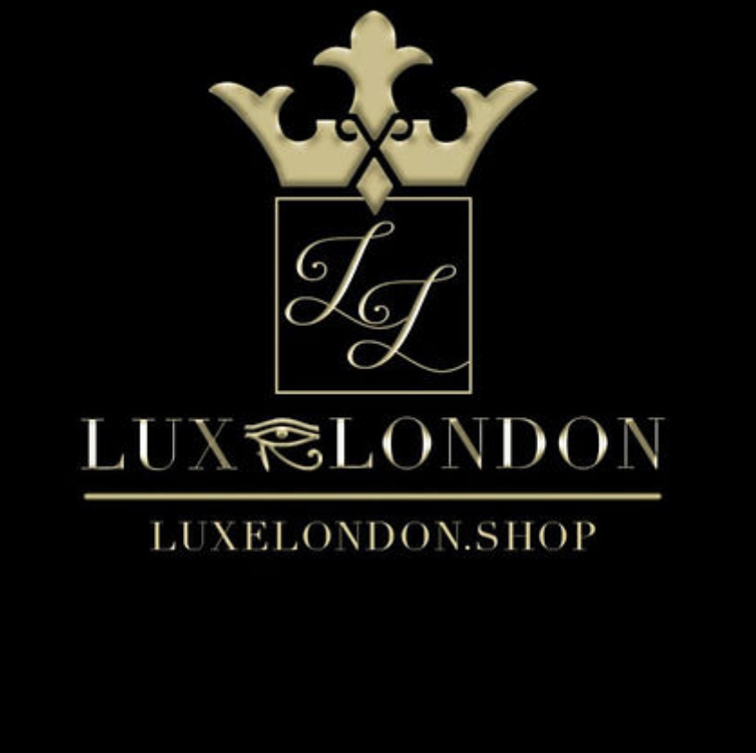
Our contact details
Name: Luxelondon.shop Limited
Registered Office Address: 63-66 Hatton Garden 5th Floor, Suite 23 London, EC1N 8LE
E-mail: info@luxelondon.shop

The type of personal information we collect
We currently collect and process the following information:
- Personal identifiers, contacts and characteristics (for example, name and contact details)
- Next of kins

How we get the personal information and why we have it
Most of the personal information we process is provided to us directly by you for one of the following reasons:
- To access professional services
- For professionals to review
- To be able to develop a client plan
We use the information that you have given us in order to review client plans.
We may share this information with other professionals.
Under the General Data Protection Regulation (GDPR), the lawful bases we rely on for processing this information are:
(a) Your consent. You are able to remove your consent at any time. You can do this by contacting info@luxelondon.shop
(b) We have a contractual obligation.
(c) We have a legal obligation.
(d) We have a vital interest.
(e) We need it to perform a public task.
(f) We have a legitimate interest.

How we store your personal information
Your information is securely stored on our hard drive.
We keep your personal information for as long as you are using the services. We will then dispose your information by deleting it off our hard drive.
Your data protection rights
Under data protection law, you have rights including:
Your right of access - You have the right to ask us for copies of your personal information.
Your right to rectification - You have the right to ask us to rectify personal information you think is inaccurate. You also have the right to ask us to complete information you think is incomplete.
Your right to erasure - You have the right to ask us to erase your personal information in certain circumstances.
Your right to restriction of processing - You have the right to ask us to restrict the processing of your personal information in certain circumstances.
Your right to object to processing - You have the the right to object to the processing of your personal information in certain circumstances.
Your right to data portability - You have the right to ask that we transfer the personal information you gave us to another organisation, or to you, in certain circumstances.
You are not required to pay any charge for exercising your rights. If you make a request, we have one month to respond to you.
Please contact us at info@luxelondon.shop, if you wish to make a request.

How to complain
If you have any concerns about our use of your personal information, you can make a complaint to us at info@luxelondon.shop
You can also complain to the ICO if you are unhappy with how we have used your data.
The ICO’s address:
Information Commissioner’s Office
Wycliffe House
Water Lane
Wilmslow
Cheshire
SK9 5AF

Helpline number: 0303 123 1113
ICO website: https://www.ico.org.uk

